Safety Planning for the Holidays Workshop Worksheet
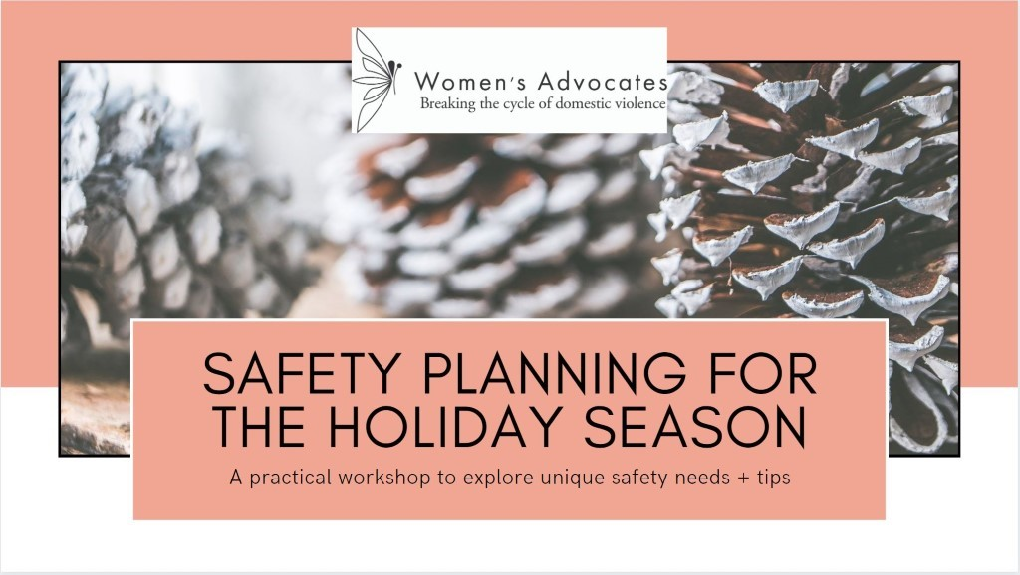
A safety plan is a personalized, practical plan to improve your safety while experiencing abuse, preparing to leave an abusive situation, or after you leave. This plan includes vital information tailored to your unique situation and will help you prepare for and respond to different scenarios, including telling your friends and family about your situation, coping with emotions, and various resources suited to your individual circumstances.
Some of the preparations for a safety plan might seem obvious, but it can be hard to think clearly or make logical decisions during moments of crisis. Having a safety plan laid out in advance can help you protect yourself and others in high-stress situations.
Source: The Hotline
Everyone is deserving of feeling safe emotionally, physically, cognitively, and collectively.
Support System- Who do you trust? Who shows up for you? Learn more about this by clicking here
Supportive Person’s Name | Relationship  to You | Address | Best Way to Contact Them (Text, Call, Social Media) | How They Can Help/What They Can Help With

Local Resources – Knowing that help from a trained, empathetic advocate is available can be comforting. Suggestions
Organization Name | Address | Contact Info (website, crisis line) | When You Would Contact Them
(Some examples: Casa de Esperanza 24-hour English/Spanish line: 651-772-1611 Asian Women United 24-hour Hmong, Cambodian, Viet, Hindu, Japanese line: 612-724-8823 Brian Coyle phone number with Oromo, Somali, Arabic, Amharic, Swahili, and English: 612-338-5282 Legal Help- Standpoint: 612-343-9842)
I’m really really scared. How do I know when to call for help? (Adapted Danger Assessment)
- Am I in fear for my life?
- Do I feel like I cannot manage my emotions/I am overwhelmed by my emotions?
- Am I afraid of what this person will do to me or someone I love?
- Do you feel threatened emotionally, physically, spiritually, financially, or otherwise by this person?
- Have you threatened or tried to kill yourself?
- Are you afraid of the insults, threats, abuse, aggression, and coercion getting worse?
*If you answered “Yes” to any of these questions, please consider calling a local domestic violence hotline or emergency services.
Self-Knowledge
Listening to your body and knowing your warning signs. Check or circle the following signs that indicate to you personally, if your safety is in question.
- You stop breathing or are breathing shallowly
- You are feeling small, helpless, young, terrified, enraged, or out of control. You want to hide.
- You are feeling immobilized, frozen stuck, hopeless, depressed, or intensely sad.
- You notice yourself thinking in “always/never”, “Black/White”, “either/or”, “now/never”
- You are feeling intensely urgent and want something to be decided right now
- You are feeling self-destructive, or like you want to hurt someone, or you’re being mean to yourself
- You are having a flashback, nightmare, panic attack, intrusive thoughts, feel regressed

How can you pause?
- If you are engaging in an activity, try to take a break from it.
- If you can, move into a different room or change your surroundings in some way
- Try to get somewhere safe where you can focus on taking care of yourself
- If possible, change the music (soothing or calming), lighting (brighten or dim), your physical position (sit up, lay down, child's pose), the taste in your mouth (something sweet or comforting)

Strategies to ground yourself in the present moment.
- Breathe slowly, deeply, with a straight back, try placing your hand on your belly
- Engage in something other than what is causing distress: TV, move, book, video game, puzzle, cards
- Focus on 5 senses, wiggle toes, focus on feel of feet on ground, orient to present
- Create boundaries: lock doors, wrap yourself in blankets, make “keep out” sign
- Move: explore the full range of movement in your joints, dance, run, exercise
- Do something with your hands: (esp. with anxiety) knit, quilt, fidget, build something, pet animals
- Listen to or sing music that can make you feel better or change your mood
- Release: allow yourself to tremble, run, kick, scream into a pillow, cry, rock, say no, shake it out
Knowing your routes to safety.
Route | Pathway | Examples
Inner Guidance | self-resourced, meaning it’s accessed primarily within oneself | self-reflective tools like journaling and meditation, having a spiritual practice, taking a moment to get in touch with one’s intuition
Sensory Experiences | self-resourced | engaging the senses, like lighting a candle, using a weighted blanket, basking in the sunlight, being in nature
Private Retreat | self-resourced | “alone time” is key: making art, watching a movie alone under a blanket, daydreaming, reading (especially in “protected” spaces, like locked door, closed curtains, lights off, etc.)
Quality Relationships | socially sourced, meaning it depends on connecting with others | having needs met by another person, experiencing repair after conflict, intimate touch, caring relationships (including pets!)
Closeness and Proximity | socially sourced | receiving or giving a hug, being by yourself but with help available if needed, doing activities you enjoy with another person, having friends who will reach out to you first
Common Humanity | socially sourced | being heard and seen, knowing you aren’t being judged, laughing with others, having hard emotions validated, having your boundaries respected
Protective Measures | action-oriented, meaning it comes from tangible action and change | someone defending you or defending yourself, being physically protected, being self-sufficient, accessing justice after harm
Structure and Certainty | action-oriented | having a consistent routine, having agency or a sense of mastery in one’s life, having financial security, developing a solution to a problem, making a schedule or plan to follow, predictability
Physical Safety Plan
Safety Planning While Living with an Abusive Partner
Safety Planning with Children
Safety Planning During Pregnancy
Safety Planning with Pets
Self-Care Plan
- Create an activity list organized around different parts of your life (e.g. work, physical wellness, emotional life, relationship/community)
- Note any barriers that may be in your way and how to shift them.
  - Barrier #1:
  - Addressing barrier #1:

  - Barrier #2:
  - Addressing barrier #2:

  - Barrier #3:
  - Addressing barrier #3:

- Print out your plan, or write it on a piece of paper to display in your room or office. Share your plan with your closest friends. Encourage them to create their own plan and share it with you.
  - I will share my plan with…
    - Person #1: __________________
    - Person #2:__________________
- Activities for a balanced work/school life:

- Activities for fueling my body:

- Activities for emotional wellness:

- Activities for social connection:

- Whenever this plan doesn’t go perfectly, I will tell myself.:

Self-Care Tips
- Wake up your skin: Take shower, wash your face, concentrate on textures
- Nurture: long bath, manicure, lotion, nap, whatever feels good to your body
- Meditate: focus your thoughts, concentrate on a mantra, visualize a safe image
- Express: create art, write, journal, talk about it, let out how you are feeling
- Take a break: make time for yourself. Let yourself do something “frivolous” just because you want to.
- Connect with something healing: nature, animals, children, friends, counselor, hotline
- Nourish your body: get sunshine, eat fresh fruits, and veggies, drink water
- Give yourself a gift: eat your favorite food, do something special for yourself, do a favorite activity, buy yourself a small present, allow yourself a small luxury
- Rewrite the story: imagine yourself doing it different, perhaps with whoever might help/protect you there helping
- Meet the need: if you are feeling out of control, do something that makes you feel in control. If you need to feel loved, do something that shows love for yourself. If you need to be cared for, do something caring for yourself. If you need to feel safe, do something that feels safe to you.

Anticipating specific situations.
Sample situations:
- You are going to a holiday gathering with your partner who is abusive. You know your parents are going to ask you about the relationship. You know your partner will act like everything is fine and expects you to do the same. You want support from your parents but you’re afraid of your partner finding out.
- You are going to a holiday gathering with your partner who is abusive. You know that they have a habit of drinking too much and also becoming violent, aggressive, and mean. You are afraid of how they will act around your partner’s family and you fear their violence escalating.
- You are attending a virtual holiday gathering with your partner’s family via Zoom. You know that around this time, your partner who is abusive will find every way to insult you. They criticize your appearance, how much you eat, and the quality of your cooking. You know that the family will justify the insults and support your abusive partner. You have felt unsupported, alone, small, and sad when this has happened in the past and you do not want to experience it again.
- The holidays are approaching and your abusive partner is pressuring you to visit their family across the country, even though he knows you do not feel safe or comfortable with traveling during the pandemic. You know they are going to ask you again or try to coerce you the day of. You are terrified of what they will do in response to your refusal.

Situation #1:
- Describe the situation.

- Who is involved? | - What are their actions? | - Where are you when this happens?
- How do their actions make you feel? | - What routes to safety are available to you? | - Who can support you? In-person and virtually
- Inner Guidance
- Sensory Experiences
- Private Retreat
- Quality Relationships
- Closeness and Proximity
- Common Humanity
- Protective Measures
- Structure and Certainty

- What can you do before? Boundaries with other people who are not abusive? | - What can you do after?  (Refer to self-care plan) | - Reminders/Affirmations

Situation #2:
- Describe the situation.

- Who is involved? | - What are their actions? | - Where are you when this happens?
- How do their actions make you feel? | - What routes to safety are available to you? | - Who can support you? In-person and virtually
- Inner Guidance
- Sensory Experiences
- Private Retreat
- Quality Relationships
- Closeness and Proximity
- Common Humanity
- Protective Measures
- Structure and Certainty
- What can you do before? Boundaries with other people who are not abusive? | - What can you do after?  (Refer to self-care plan) | - Reminders/Affirmations

