HONORARIUM PROCEDURE
Women’s Advocates is dedicated to breaking the cycle of domestic violence in our community. As part of our commitment to safety, we provide education and outreach to increase awareness of the warning signs of domestic violence, to increase pathways to safety for people who are in abusive relationships, and to prevent controlling behaviors in relationships. This outreach and education comes at a cost to our organization, and any support we can receive for our efforts will make a difference. Women’s Advocates is a 501 (c)(3) nonprofit organization, tax ID 23-7310701.
A common honorarium for a one-hour speaking engagement is $200. Women’s Advocates does not want this standard to preclude anyone’s request for our education and outreach, and for those whom this honorarium is not financially viable, we accept any other amount down to $0.

All honorarium payments should be made out to Women’s Advocates, Inc.

Resources available and following this page:
- Women’s Advocates’ W-9 form
- Honorarium Invoice Template

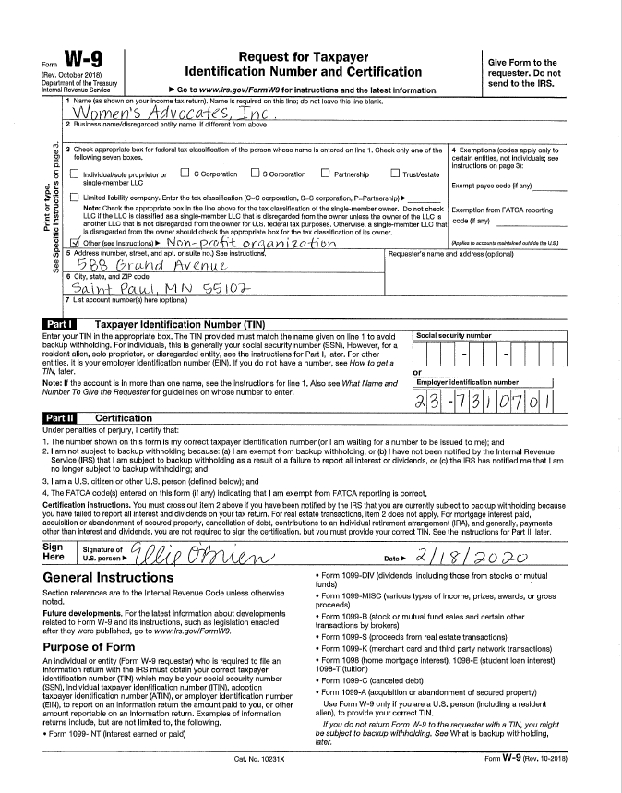
HONORARIUM INVOICE
DATE OF INVOICE: ___________________________________
ORGANIZATION: ___________________________________
CONTACT NAME: ___________________________________
CONTACT TITLE: ___________________________________
E-MAIL: ___________________________________
INVOICE AMOUNT: ___________________________________
PRESENTATION TITLE: ___________________________________
PRESENTATION DATE: ___________________________________

Please make checks payable to Women’s Advocates, Inc.
PO Box 4039
Saint Paul, MN 55104

Women’s Advocates’ mission is to walk with victim-survivors and our community to break the cycle of domestic violence. Women’s Advocates will use honorarium proceeds to support its comprehensive resources for women and children seeking stability and safety, as well as domestic violence awareness education throughout the community. Resources are provided at the shelter in Saint Paul, Minnesota, and include intensive, individualized case management, legal and systems advocacy, children’s programming and activities, support groups, and education and employment assistance.
Women’s Advocates will not use any of these funds to lobby any unit of government. No goods or services will be provided for consideration, in whole or in part, for this contribution.
WOMEN’S ADVOCATES’ TAX IDENTIFICATION NUMBER 23-7310701

